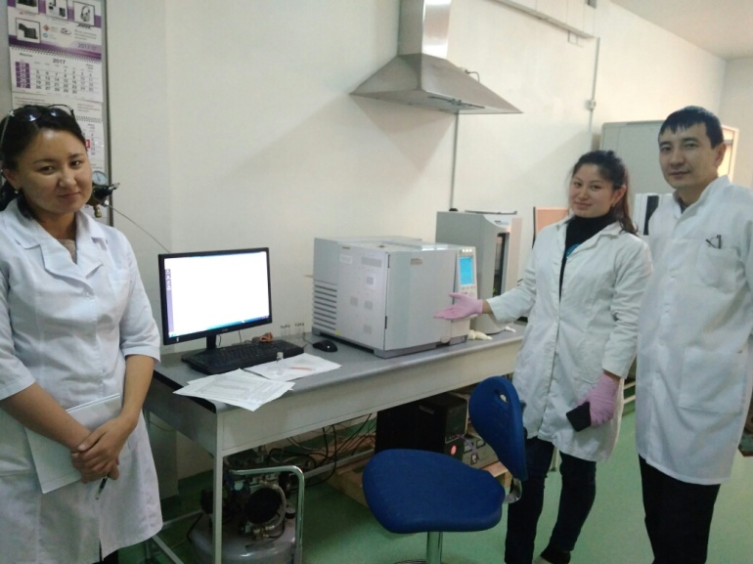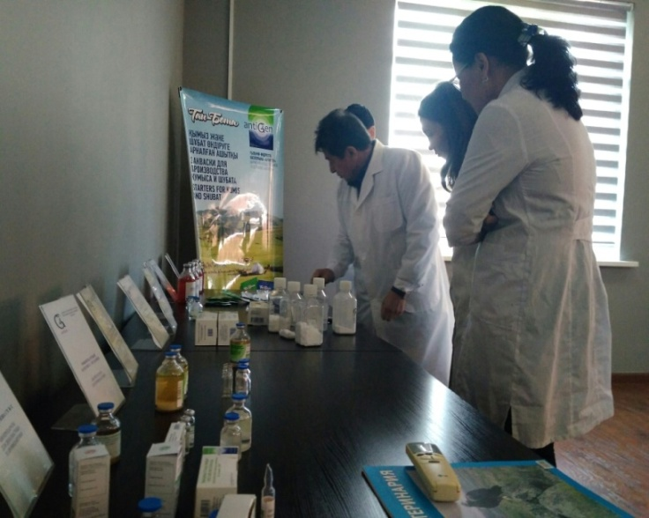
LLC Scientific and production enterprise "Antigen" and Department "safety and quality of food products" of Almaty technological University
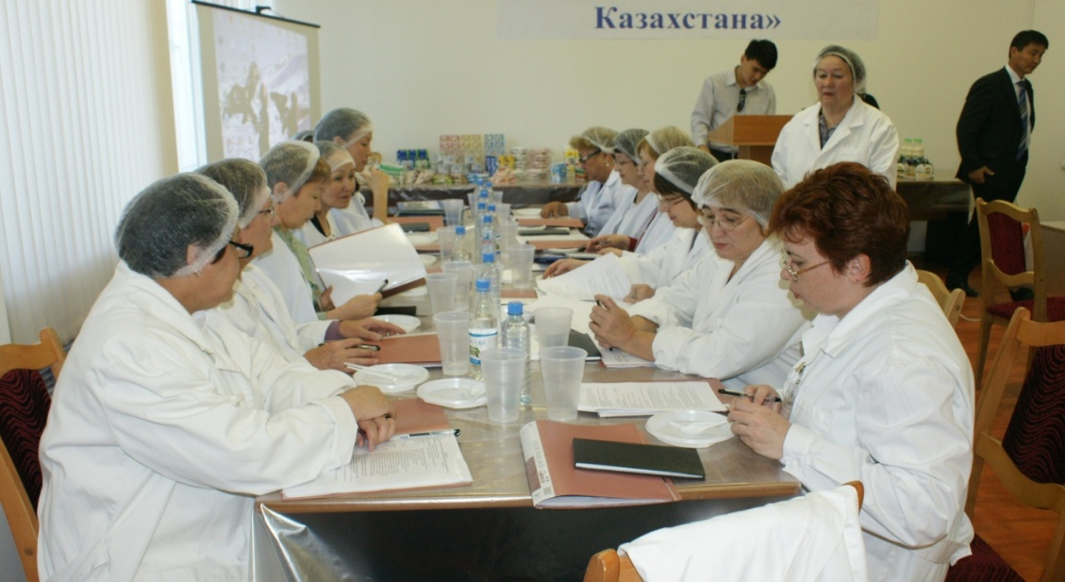
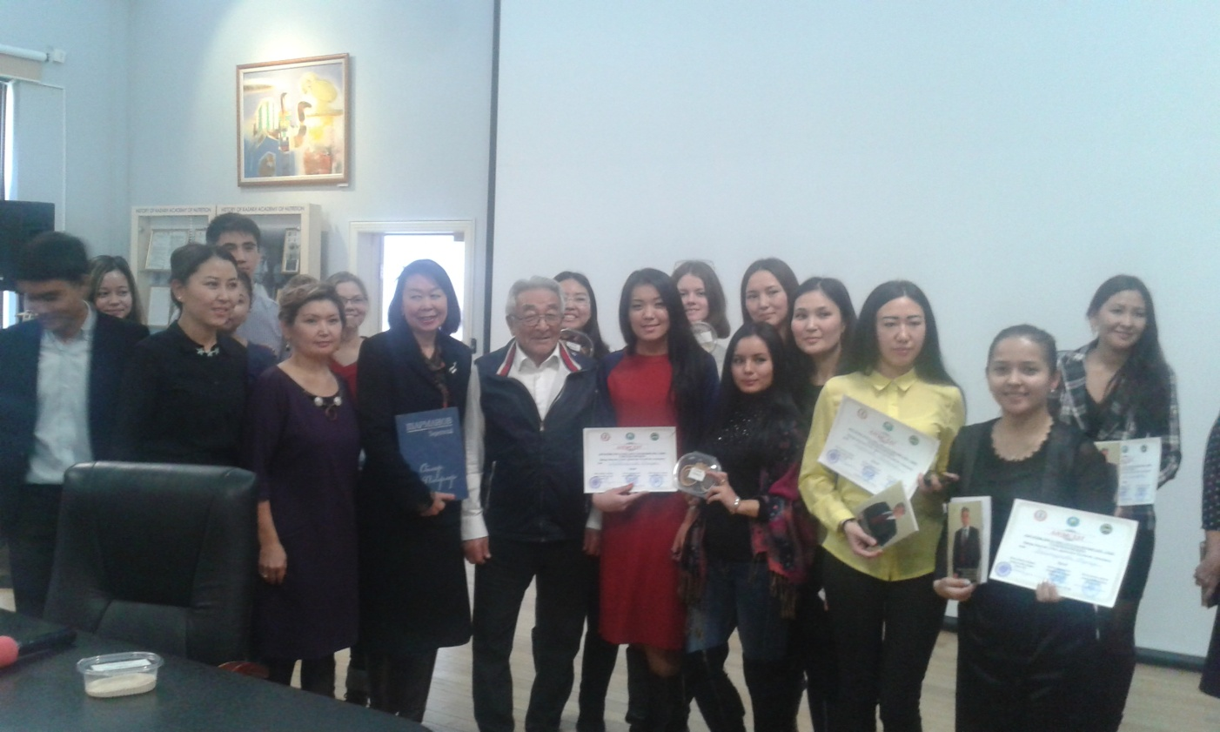
Awarding of students, undergraduates, doctoral students in the specialty "Standardization and certification of food products" "Safety and quality of food products" of Almaty technological University

